8 channel DTMF controller commands setting manual
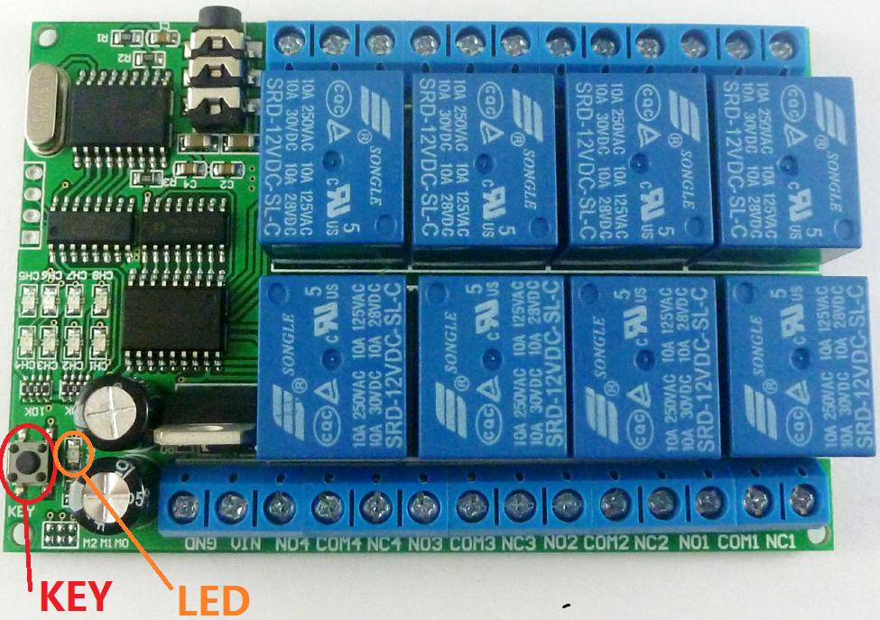
By default, The AD22A08 8 channel DTMF controller commands are saved in 8 numbers, ‘1,2,3,4,5,6,7,8.’ but you can also modify appropriately the coding instructions with arbitrary 1-4 four bits (0,1,2,3,4,5,6,7,8,9).
The controller has two models, "operating mode" and "setting model". The default is "operating mode", but it will be changed into an "setting model" when you press its "key" button.
Factory settings: If you forget the instructions you set before, you can reset it: Keeping pressing consistently the key button about 10 seconds until you see that the LED lights on again. After that, the product of operations will restore to its default commands, ‘1,2,3,4,5,6,7,8.’.

The setup processes:
First, the DTMF controller should work properly, guaranteeing its power supply and audio cable are connected correctly.
Second, as pressing the key-button, the LED lights off, the product will go into the "setting model".
Thirdly, begin to input commands with mobile phone or computer.
Fourthly, when finished the third step, activating the product of key- button or powering it up again.

DTMF controller commands format :
initiate(1 bit) | Relay Number (1bit) | order（4bits） | ending(1bit)
# | 1~8 | arbitrary 1-4 four bits | *
For instance:

1 The instruction of relay 1 was changed to:2011
In the setup mode, input: #12011*

2：The instruction of relay 1 was changed to: 2012
In the setup mode, input: #22012*

3 The instruction of relay 1 was changed to :2013
In the setup mode, input:#32013*

4 The instruction of relay 1 was changed to: 2014
In the setup mode, input:#42014*

Notes:
No1. Ensure that the controller is working and then start to set it.

No2. Commands must be choose from "0123456789" in these 10 numbers

No3. Command length cannot be greater than 4 bits .

